CTLCS Facilitators
Friday, August 12th, 2016

Instructions for Session Facilitation:
Building System Capacity for Student Success
Fraser Public Schools
http://www.fraser.k12.mi.us

Thank you for helping with today’s facilitation! As we work through today’s session, please make sure the participants have access to today’s content and resources. They will need these tools to complete the activities throughout the presentation.

Web Link for Resources:
http://frasercbl.weebly.com/

Click on the Second Tab: CTLCS 2016 Conference

Below is a screen shot for the web resources:

Link to Table Activity (Google Doc):

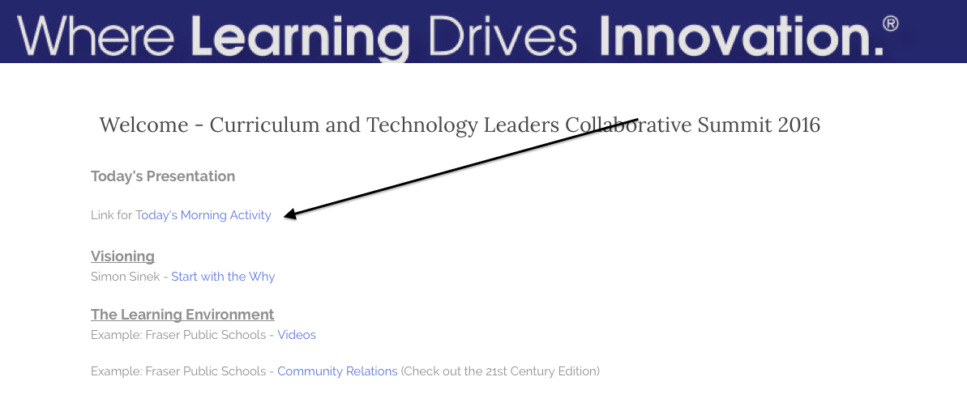

Table Activity Response Log:

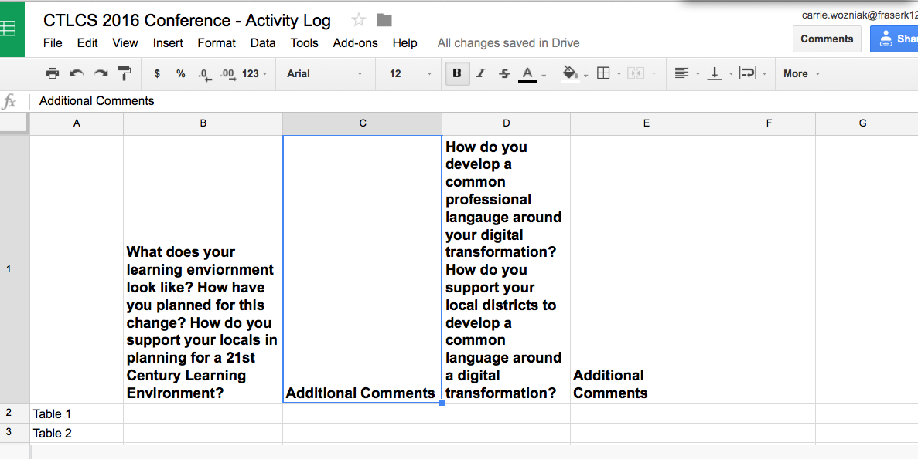

Your role in the Table Activity:
To make sure everyone has a voice at your table and provide the summary (notes written in the Google Doc for your Table) of the conversation.

Please let us know if you have additional questions or concerns.

Thank you!

